LOAN PROJECT SQL QUERIES

***DATASETS:***

* account.csv
* card.csv
* client.csv
* disp.csv
* district.csv
* loan.csv
* order.csv
* transaction_data.csv

**EXPLORATORY DATA ANALYSIS(EDA):**

Counting the number of records in each table.

*QUERIES:*

select Count (*) from [dbo].[account]

select Count (*) from [dbo].[card]

select Count (*) from [dbo].[client]

select Count (*) from [dbo].[disp]

select Count (*) from [dbo].[district]

select Count (*) from [dbo].[loan]

select Count (*) from [dbo].[order]

select count(*) from [dbo].[transaction_data]

**SOLUTION APPROACH:**

In this project, the raw data is stored in the database and form there all the ETL functionalities has to be performed as follows.

*Datasets Entity Mapping:*

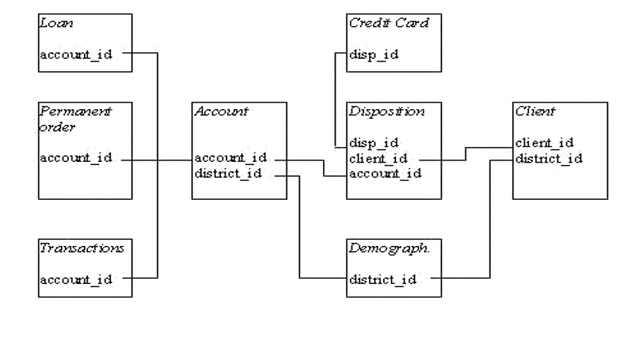 By the above-mentioned entity mapping, master table is to be created that takes into consideration all the related tables above mentioned. The client id is the common to all from which relationship can be built.

**DATA TRANSFORMATION:**

*Transaction Data and Loan Table:*

Joining the transaction Data table and Loan table using inner join.

select * into loan_trans from (select td.*, ln.loan_id, ln.date loan_date, ln.amount loan_amount,ln.duration loan_duration, ln.payments loan_payments, ln.status loan_status from loan ln join transaction_data td on ln.account_id = td.account_id)A

**Viewing the Merged Table.**

select * from [dbo].[loan_trans]

*Account and Orders Table:*

Joining the Account Table and Orders Table using inner join.

select * into acc_ord from (select o.*,acc.date account_date, acc.district_id as account_district_id, acc.frequency as account_frequency from account acc left join[dbo].[order] o on acc.account_id = o.account_id)B

**Viewing the Merged Table.**

select * from [dbo].[acc_ord]

*Card and Disposition Table:*

Joining the merged card and Disposition Table with Client Table based on client id using inner join.

select * into card_disp from (select card.*, disp.account_id disposition_account_id, disp.client_id as disposition_client_id, disp.type as disposition_type from card card join disp disp on card.disp_id = disp.disp_id)C

**Viewing the Merged Table.**

select * from [dbo].[card_disp]

*Card – Disposition and Client Table:*

Joining the Merged Card, Disposition Table with Client Table based on district id using inner join.

select * into card_disp_client from (select * from card_disp cd join client c on cd.disposition_client_id = c.client_id)D

**Viewing the Merged Table.**

select * from card_disp_client

*Card – Disposotion – Client and District Table:*

Joining the Merged Card, Disposition and Client Table with District Table based on district id using inner join.

select * into card_disp_client_dist from (select * from card_disp_client cdc join district dist on cdc.district_id = dist.A1)E

**Viewing the Merged Table.**

select * from card_disp_client_dist

*Account-Order and Card-Disposition-Client -Disrtict Table:*

Joining the Merged Account and Order Table with merged Card, Disposition, Client and District Table based on account id using left join.

select* into acc_ord_card_disp_client_distfrom(select cdcd.*,ao.order_id,ao.bank_to,ao.account_to,ao.amount,ao.k_symbol,ao.account_date,ao.account_district_id,ao.account_frequencyfrom acc_ord ao left join card_disp_client_dist cdcd on ao.account_id= cdcd.disposition_account_id)F

**Viewing the Merged Table.**

select * from [dbo].[acc_ord_card_disp_client_dist]

*Master Table:*

Joining and Viewing the merged Account, Order Card, Disposition, Client, District with merged Transaction Data Table and Loan Table using inner join.

select * from acc_ord_card_disp_client_dist aocdcd join loan_trans lt on lt.account_id= aocdcd.disposition_account_id